Assets visibility & control

Improved asset utilization

Audit requirement compliance

Regulatory requirement compliance

Reduced costs of software and hardware

The tool we use here is ***Assets Tiger.***

* Go to browser search for assets tiger. > Click on first link.

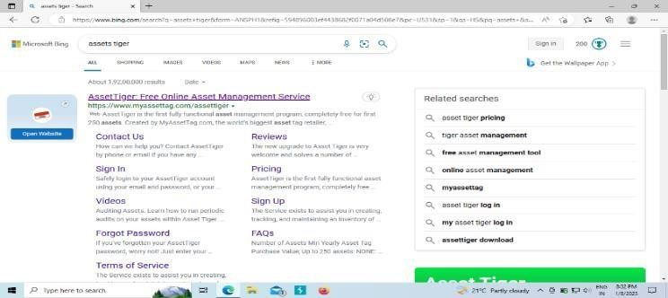

* Click on create new account.

* Enter your first name, last name, Email id, password , retype password and agree the teams and private policy > Click on sing up. You will get a message to your email.

* Verify email in your mobile by filling all the fields. Complete all steps.
* Once you finish the process go back to sign in option just enter your email id and password. Now you can see the dashboard page.

* Now you can see the information like number of active assets, values of assets. Below you’ll see various charts, calendar and feeds to learn more about the current status of each asset ,you can make a vertical or horizontal graph also.

* Upper right you have option “mange dashboard”. User may create your new dashboard or changes the setting of your dashboard.

­­­­­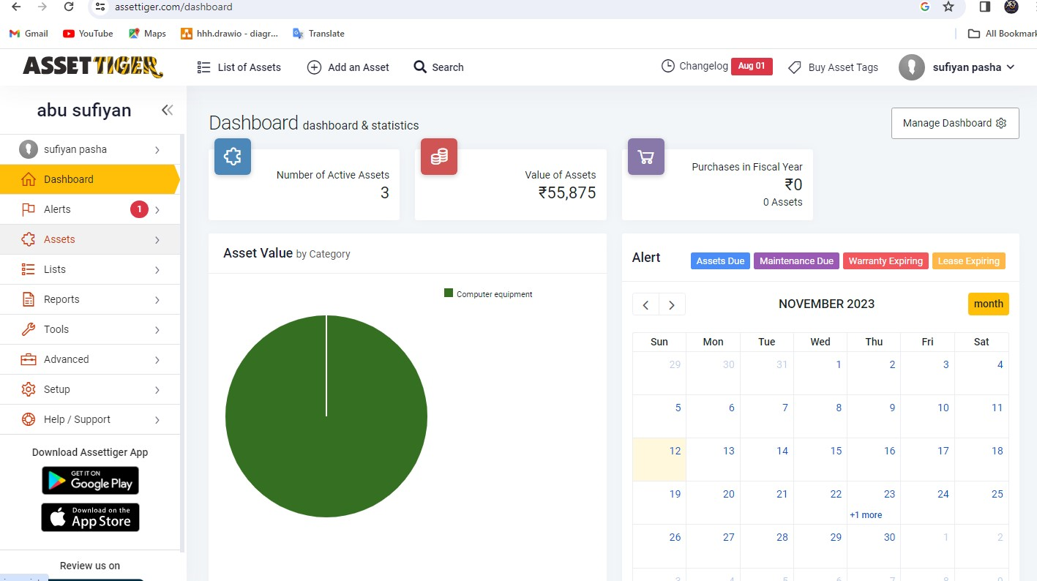 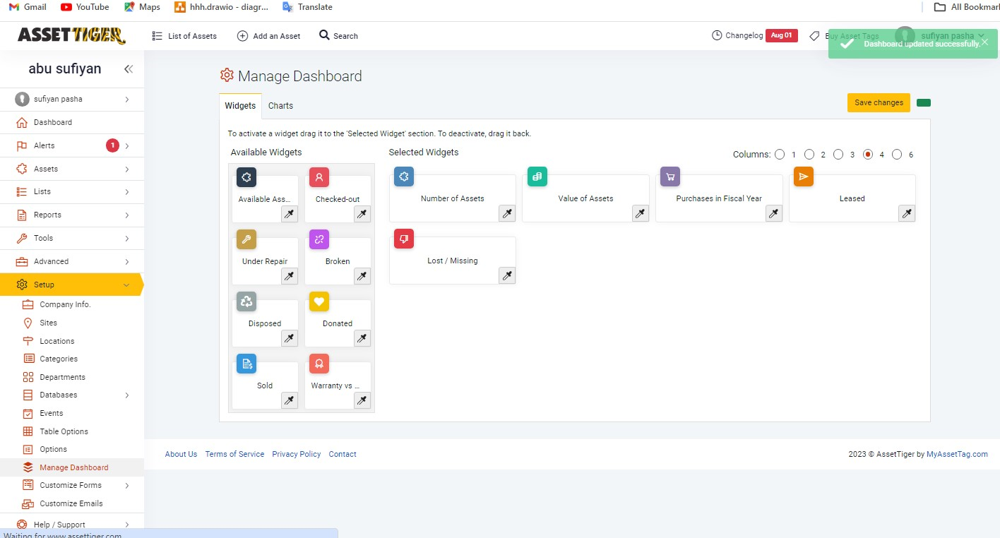

* On left side of asset tiger. Choose tools option > click on download templates.

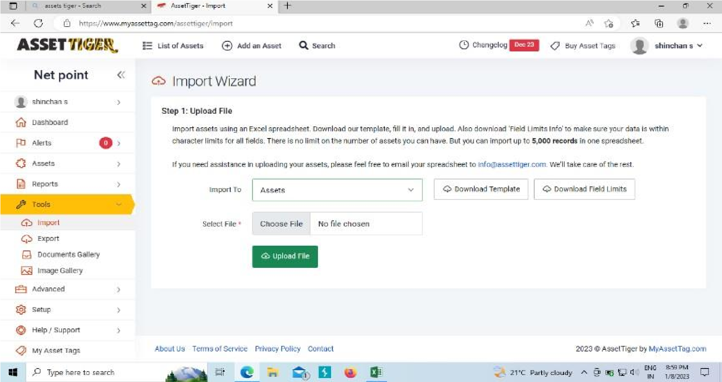

* Open the downloaded Excel file and Fill some sample assets details.

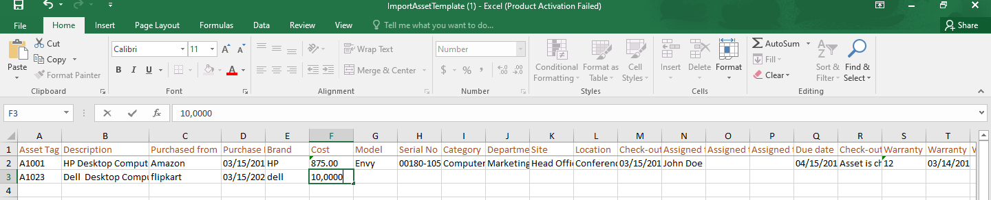

* Save the file in excels format
* On asset tiger upload the file which was saved in system and click on upload file.

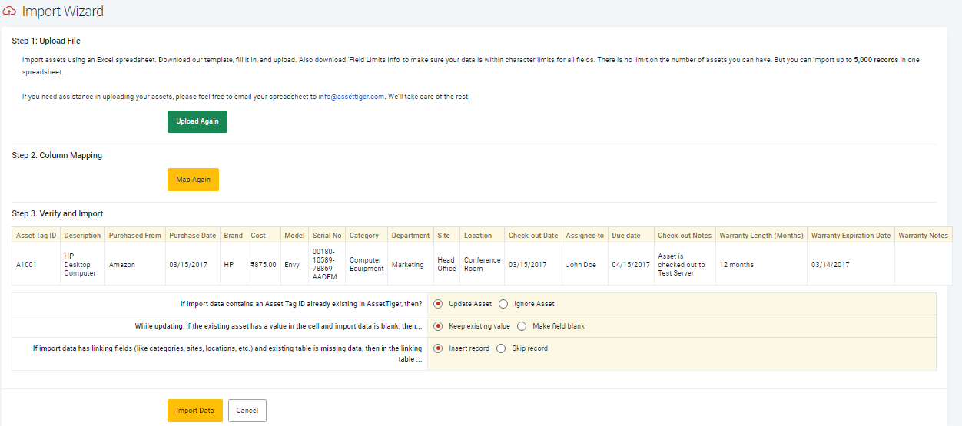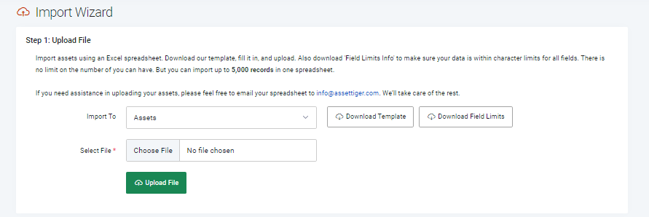

* Click on preview and Click on import data.
* Go to assets > click on list of assets.
* If you want to edit asset details, click on view option. Click on edit asset. Click on submit.

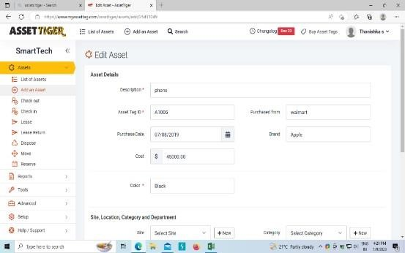

* Now you can see the changes of your database.

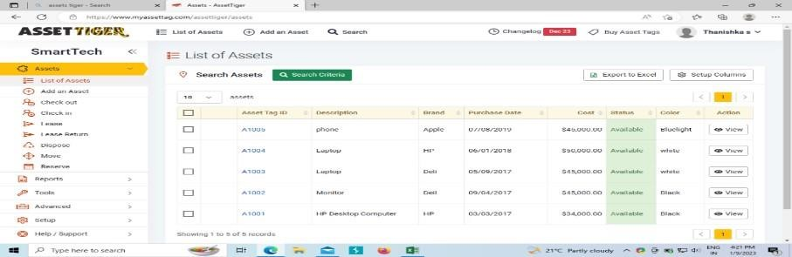

* Now go to Assets. There you can see options like Add an Asset, check out, check in, lease, lease return, dispose, move, reserve . Click on lease and select assets.

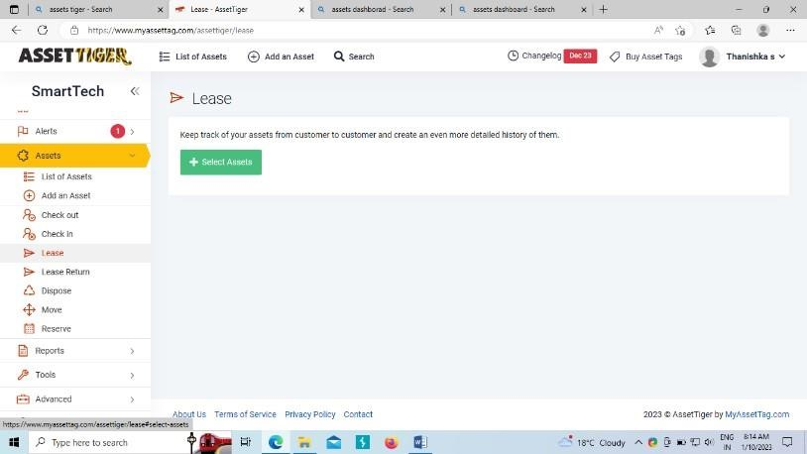

* Add the selected asset. Here lease is used to provide requirements for the customers for particular time.

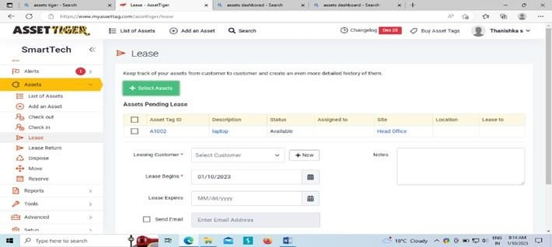

* Now select new in leasing customer and fill all the credentials.

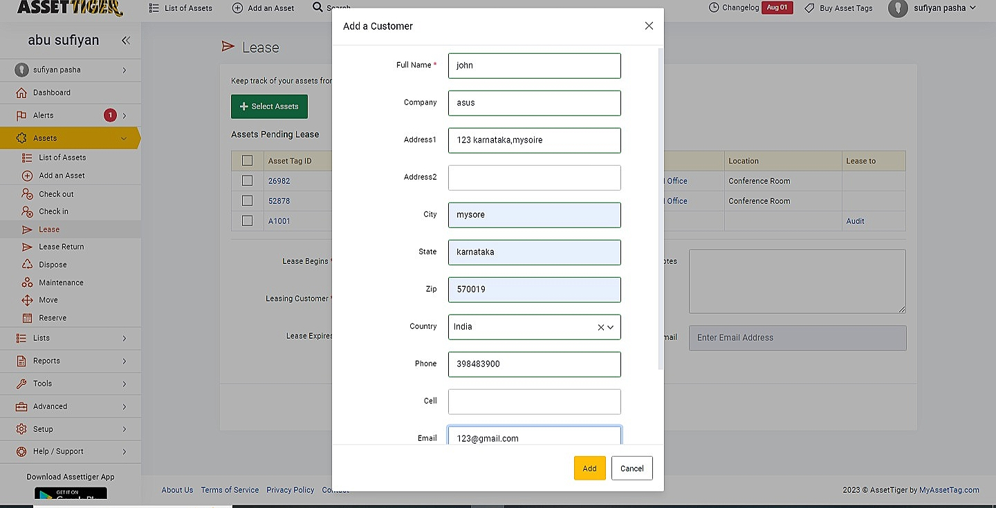

* In left side you see report option, Click on it. There you can see types of reports such as automated, Custom, Asset report, Check-out reports. Under leased report you can analyze the leased done by Customer, by Asset tag, by Due date, by Past date.

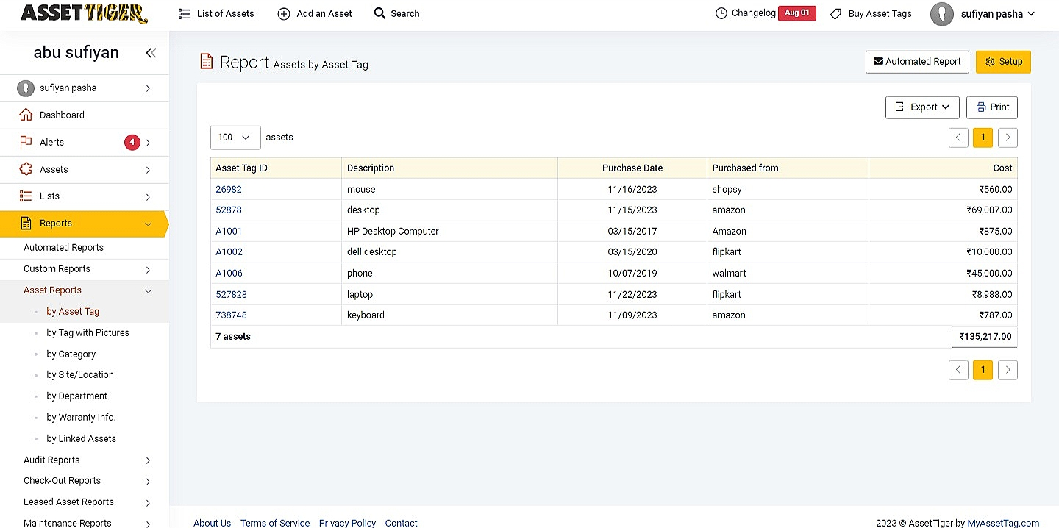

* 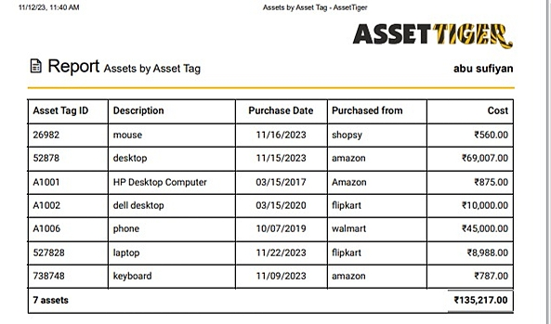This is the final report of assests which we have created.
* 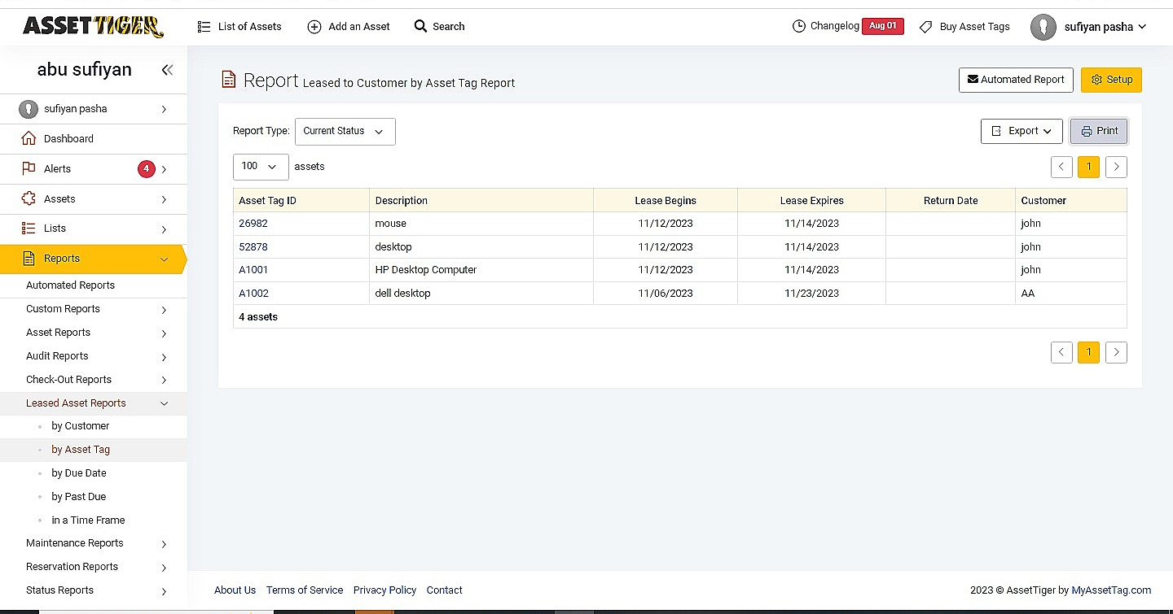Here is the leased to customer by assest tag report .
* 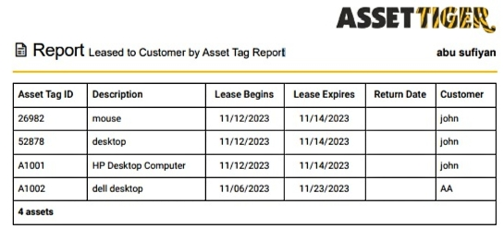This is the final report of leased to customer by assest.